New Release "All of you” by Eka Laki
Georgian singer-songwriter Eka Laki released her single "All of you” with Funk Lord. And it is available on all streaming platforms.
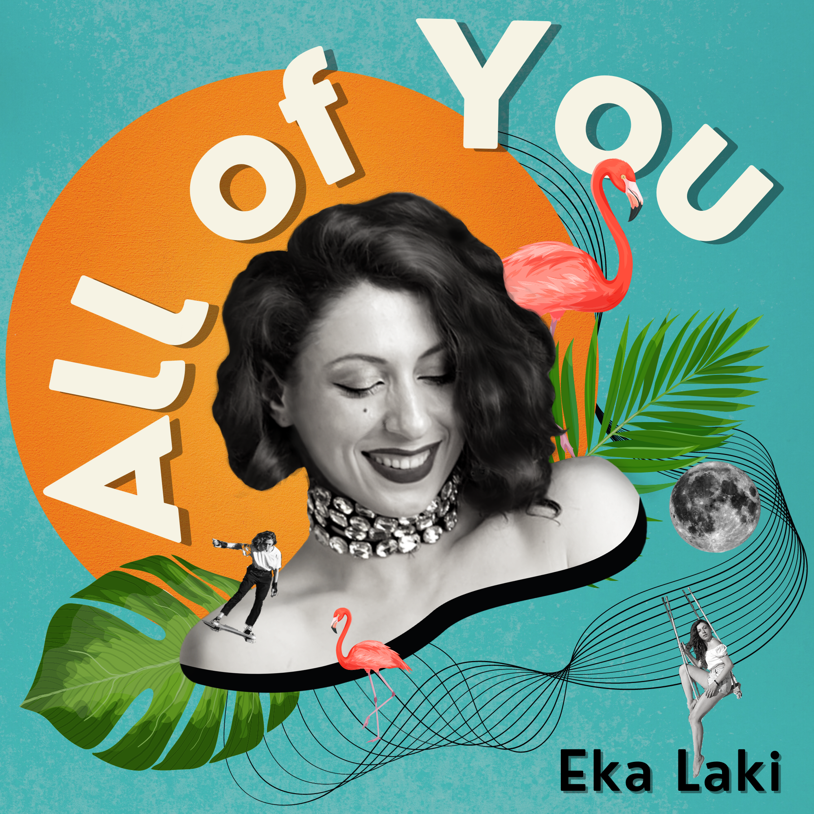 | Title: All of you  Artist: Eka Laki  Release Date: 15 July 2021  Genre: Pop/Funk/Dance  Produced By: FunkLord

About the song
“All of you” is a hymn for anyone who had an adventurous summer romance. The song can be your perfect warm-weather escape while sunbathing under the hot sun or enjoying a beautiful view from the mountains.

The song is about lost love and the realization of that loss. Eka came up with the idea when she listened to one of her friend's instrumentals. The lyrics came to her very easily - as she points out.

The song went through a lot of changes for the past year and ended up as a warm summer tune.

The collaboration between Eka and the German producer Funk Lord was very successful. The two artists are already working on a second song that will be released in the upcoming months. Eka started writing her songs less than two years ago and is experimenting a lot with her ideas.

Short bio
Eka Laki is a pop-indie singer, songwriter & performer from Georgia. Her soulful vocals and cascading beats are inspired by artists like James Blake, Rosalia, and Pharrel Williams. Eka Laki relaunched her singing career after moving to Amsterdam in 2018. She released her first single “Free Me” with Bruno Rex. The two later released “Better Than You” which was accompanied by a music video self-directed by Eka Laki. Eka is currently preparing the release of her debut album in 2022.

Headline suggestions

Georgian singer Eka Laki drops her single “All of you” for hot summer days.

Lighthearted melodies and summery vibes, Georgian singer-songwriter Eka Laki is back with her new single “All of you”

“All of you” is a song you want to listen to this summer, Georgian singer-songwriter Eka Laki drops her new single to give you sunny vibes.

Useful Links
Website: https://ekalaki.com
Instagram: https://www.instagram.com/eka_laki/
Facebook: https://www.facebook.com/ekalakii/
Spotify: http://bit.ly/ekalaki
YouTube: http://bit.ly/eka-laki-youtube

Contact: ekaabalaki@gmail.com

