New Release "Change My Mind” by Eka Laki
“Naa, na, na, na, na” Georgian singer-songwriter Eka Laki released her single "Change My Mind”. And it is available on all streaming platforms.
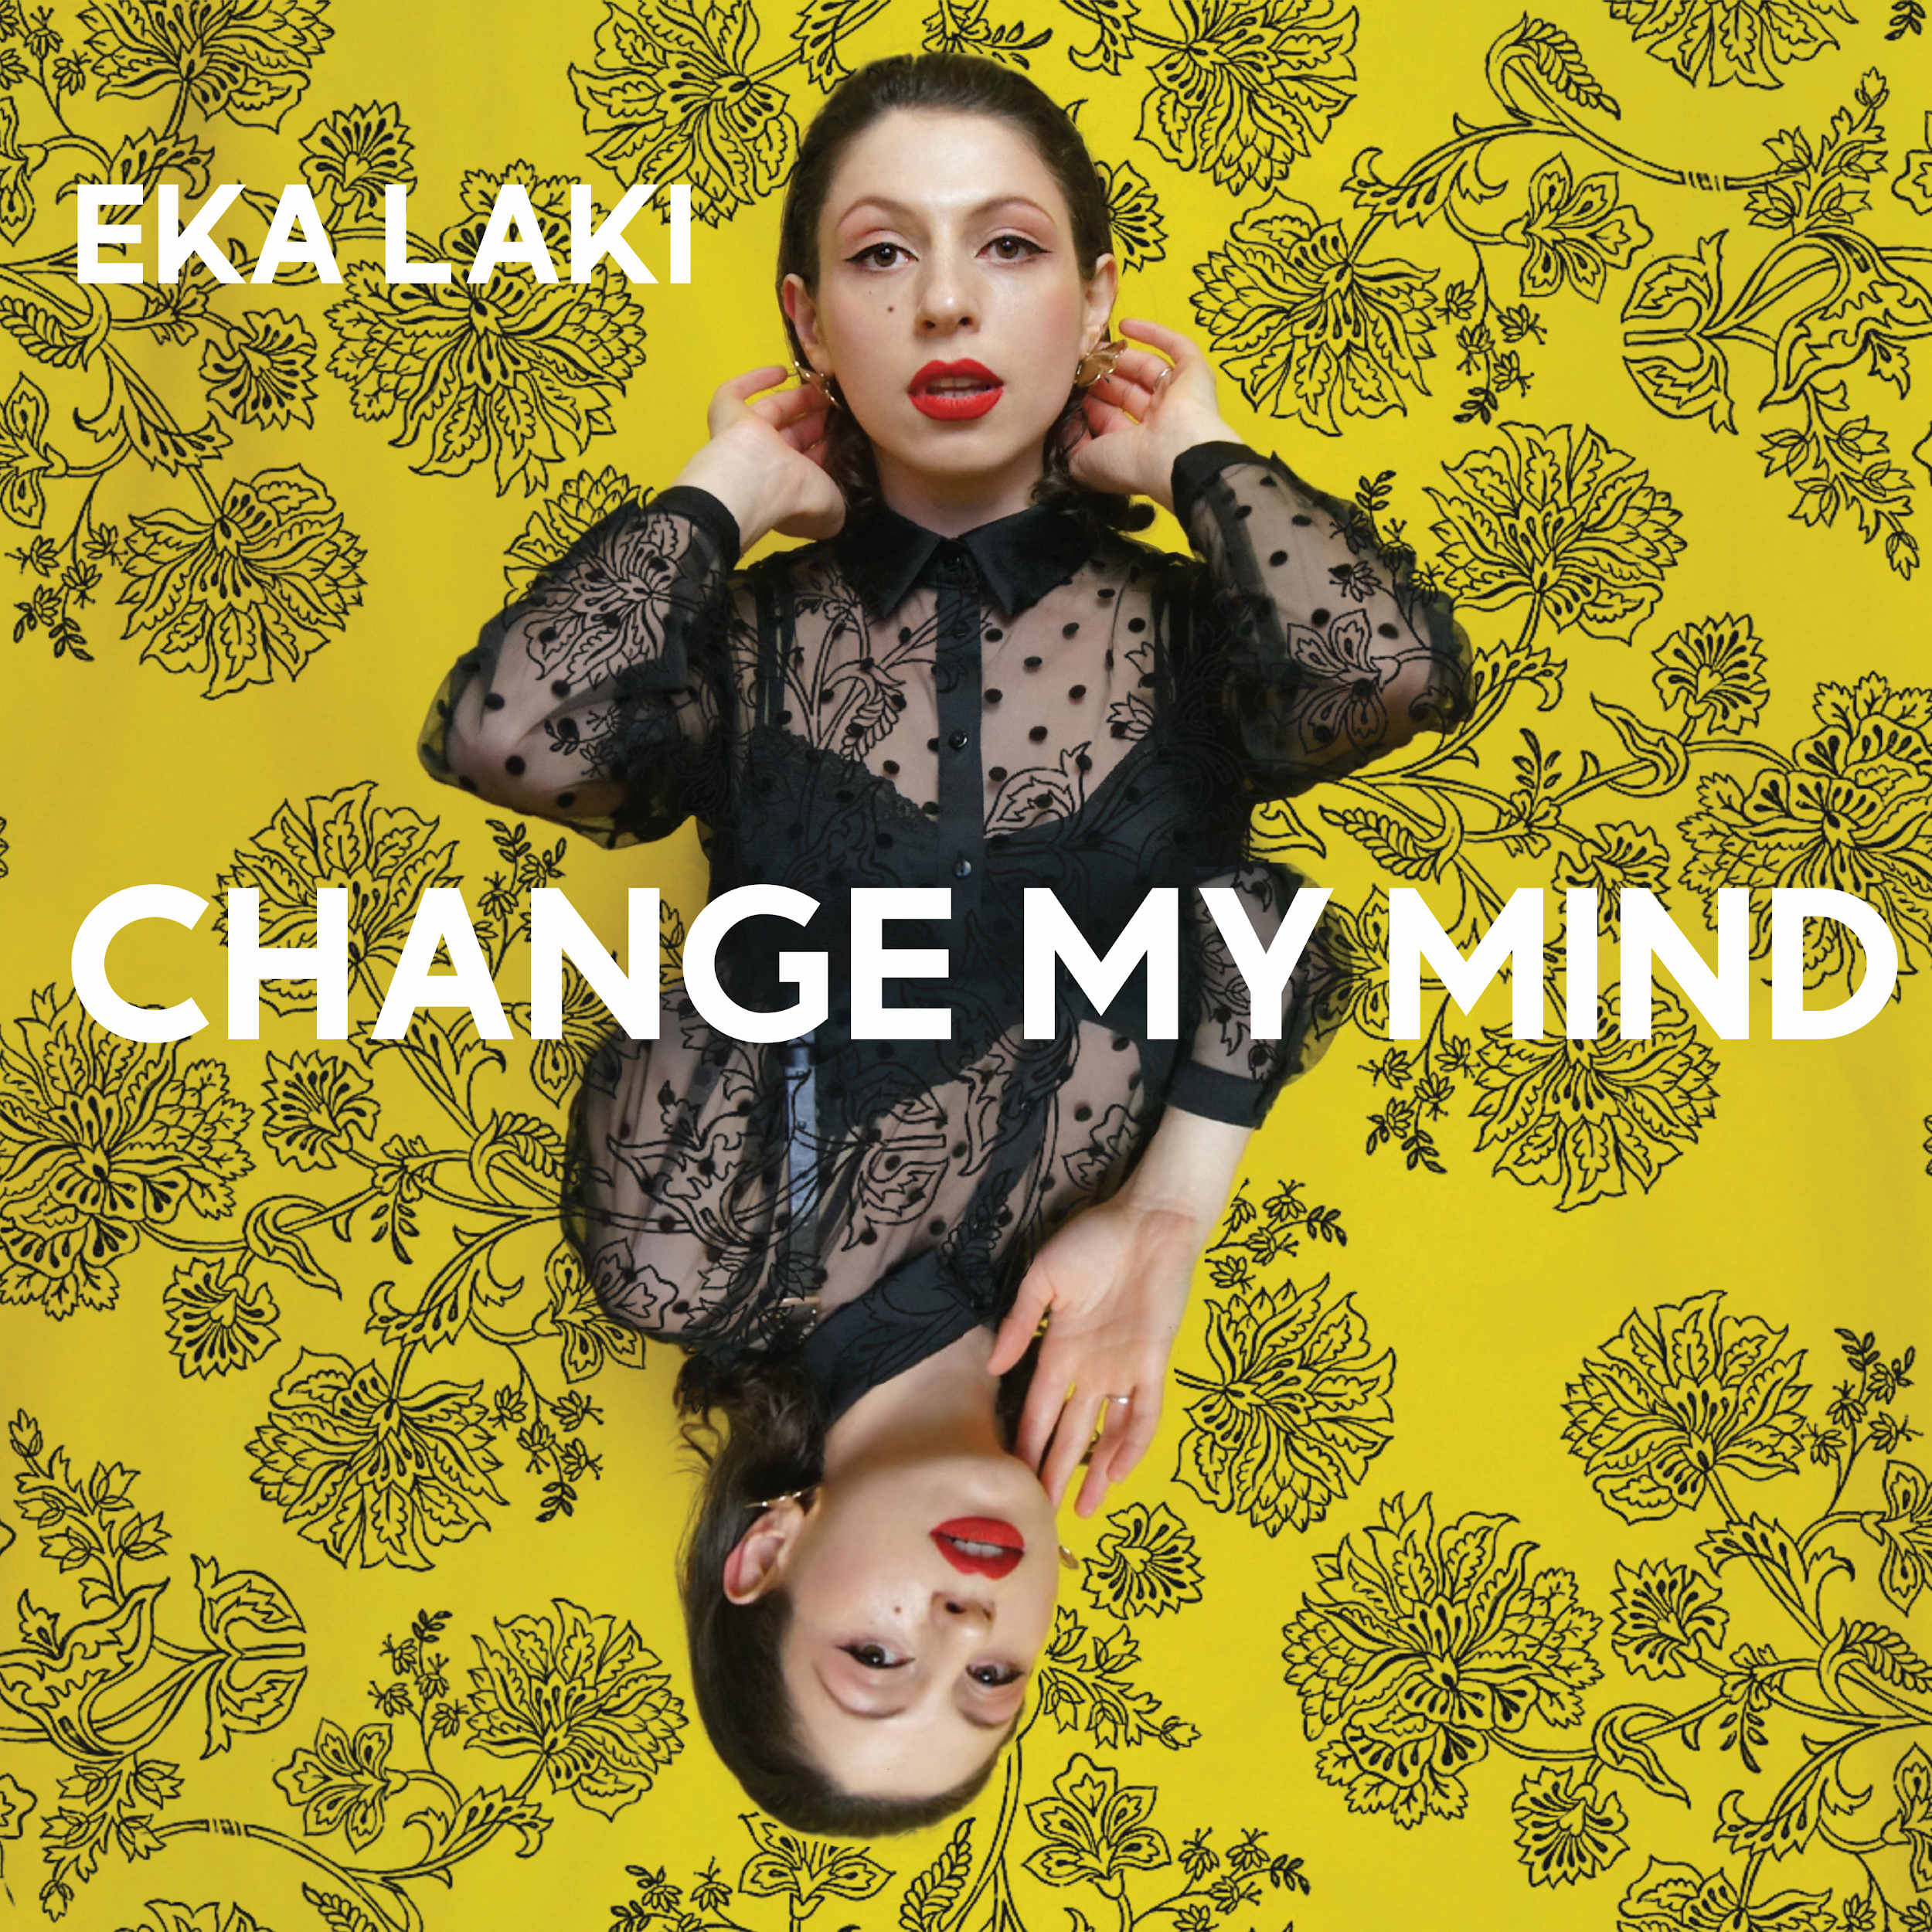 | Title: Change My Mind  Artist: Eka Laki  Release Date: 13 Oct 2020  Genre: Pop/Electro/Dance  Produced By: Alberto Hernandez

About the song
The song is full of dark musical elements complemented with engaging and lighthearted lyrics. It is a hymn for anyone who feels underappreciated and afraid to move on. Eka mentioned, ”If someone doesn’t treat you the way you deserve, you need to make a brave choice and change your mind. That’s how you discover new possibilities”.

The collaboration between Eka and the Portuguese musician, Alberto Hernandez, was very successful. The two artists are already working on a second song that will be released in the upcoming months. Eka started writing her own songs less than 1 year ago and is experimenting a lot on her ideas.

Short bio
Eka Laki is a pop-indie singer, songwriter & performer from Georgia. Her soulful vocals and cascading beats are inspired by artists like James Blake, Rosalia, and Nicole Bus. Eka Laki relaunched her singing career after moving to Amsterdam in 2018. She released her first single “Free Me” with Bruno Rex. The two later released “Better Than You” which was accompanied by a music video self-directed by Eka Laki. Eka is currently preparing the release of her debut album in 2021.

Headline suggestions
- Georgian singer, Eka Laki drops her single “Change My Mind” to celebrate strong and independent women
- Dark textures and cascading beats, Georgian singer-songwriter Eka Laki is back with her new single “Change My Mind”
- I’ll “Change My Mind”. Georgian singer-songwriter Eka Laki drops her new single to celebrate strong and independent women

Useful Links
Website: https://ekalaki.com
Instagram: https://www.instagram.com/eka_laki/
Facebook: https://www.facebook.com/ekalakii/
Spotify: http://bit.ly/ekalaki
YouTube: http://bit.ly/eka-laki-youtube

Contact: ekaabalaki@gmail.com

